Calculation Strategies used by Year 5 children
Alison Borthwick and Micky Harcourt-Heath
University of East Anglia

When working on mathematical questions, children choose from a range of calculation strategies. Although the NNS advises that different methods are taught for each of the four operations, this research shows that children often find it difficult to choose the most efficient and effective in order to answer the question. This paper reports on the findings from a sample of Year 5 children who were given questions from a QCA paper and it examines the range of strategies used by them.

Introduction
One of the features described by the NNS Framework (DfEE, 1999) as contributing to ‘numeracy’ is ‘an ability to calculate accurately and efficiently, both mentally and with pencil and paper, drawing on a range of calculation strategies’ (p.4). In the current climate, with the NNS about to undergo its first re-write, we consider the section on calculations and explore children’s calculations strategies with all four rules.
In 1999, when the NNS was first launched, comparisons were made between the UK and other countries deemed more successful in their approach to teaching number,
Most countries … avoid premature teaching of standard written methods in
order not to jeopardise the development of mental calculation strategies.
(DfEE, 1999 p.7)
Clarke and Kamii (1996) have already shown through their research that children often resort to inefficient methods, such as tallying or counting in ones. In its guidance on written calculations the NNS recognised that while standard written methods are ‘reliable and efficient procedures for calculating’ they are ‘no use to someone who applies them inaccurately and who cannot judge whether the answer is reasonable’ (p.7).
The children involved in this study are all ‘products’ of the NNS. In 1999, when the NNS was launched nation-wide, these children were just beginning school in their Reception year. This paper considers how far the process of teaching children to calculate has moved forward since the inception of the Framework. We explore if children are using a range of strategies and examine which these are.

methodology and context
The research reported here is a study carried out during the Summer Term of 2006. Data was collected from test papers completed by Year 5 children from 22 schools throughout Norfolk. A range of Primary, Junior and Middle School settings were selected. Responses to four questions from each of 995 papers were analysed for their calculation strategies. One question each for addition, subtraction, multiplication and division was used. The four questions we selected were chosen as they had no context, and required children to perform a calculation (as opposed to less abstract problems that involve children in some interpretation before a calculation can be carried out).

findings
The categories for strategies that children used are based upon the NNS suggestions. Where we could not determine the strategy a child had used, or where the strategy fell outside our categories, or indeed, where children provided no response, we have included these in the category labelled ‘other’.

Addition
90% correct / 10% incorrect
546 + 423 | Number Correct | Number Incorrect | Percentage Correct | Percentage Incorrect
Standard algorithm | 249 | 13 | 95 | 5
Number Line | 12 | 7 | 63 | 37
Partitioning | 275 | 22 | 93 | 7
Expanded vertical | 54 | 4 | 93 | 7
Other | 304 | 55 | 85 | 15
Totals | 894 | 101 | 90 | 10
Table 1: Results from 995 children for addition question.
Out of all the questions we looked at, the addition was least useful in terms of what it tells us because it did not involve any ‘bridging’ through either ten or one hundred and so no conclusions about the effectiveness of the standard algorithm against other methods can be drawn. Responses were recorded as ‘standard algorithm’ where children had re-written the calculation vertically, although this does not necessarily mean that the calculation was completed in this way.

Subtraction
42% correct / 58% incorrect
317 – 180 | Number Correct | Number Incorrect | Percentage Correct | Percentage Incorrect
Standard Algorithm | 99 | 90 | 52 | 48
Number Line | 126 | 20 | 86 | 14
Negative Number | 15 | 10 | 60 | 40
Counting On | 53 | 7 | 88 | 12
Other | 129 | 446 | 22 | 78
Totals | 422 | 573 | 42 | 58
Table 2: Results from 995 children for subtraction question.
Where answers were correct, responses fell into three main categories. 10% of the whole sample of children used the standard algorithm (decomposition or equal addition recorded vertically), 13% of children used a number line and 13% of children used ‘other’ strategies. Counting on was used effectively by 5% of the children.
With the increased emphasis in teaching subtraction by counting on using a number line model (Anghileri, 2000; Thompson, 1999) we expected to see a higher proportion of children choosing this strategy. Where a number line was used, however, a high proportion of the answers were correct (13% of the whole sample correct compared with only 2% incorrect). Compared to this, almost half of the children choosing to use the standard algorithm answered incorrectly (10% of the whole sample of children answered correctly compared to 9% answering incorrectly).

Multiplication
22% correct / 78% incorrect
56 x 24 | Number Correct | Number Incorrect | Percentage Correct | Percentage Incorrect
Standard Algorithm | 20 | 49 | 29 | 71
Grid Method | 156 | 84 | 65 | 35
Expanded Vertical | 25 | 57 | 30 | 70
Other | 22 | 582 | 4 | 96
Totals | 223 | 772 | 22 | 78
Table 3: Results from 995 children for multiplication question.
Where answers were correct, 16% of the whole sample of children had used the grid method and 2% of children had used each of the remaining three strategies; the standard algorithm, the expanded vertical method or ‘other’ strategies.
When using the grid method, twice as many children answered correctly as incorrectly (156 children correct compared to 84 incorrect). When this method was used and the answer was incorrect, the method was usually sound but elements of the mental mathematics required along the way were incorrect. For example, children recorded an answer of 100 for the partial product of 50 x 20.

Division
21% correct / 79% incorrect
222 ÷ 3 | Number Correct | Number Incorrect | Percentage Correct | Percentage Incorrect
Standard Algorithm | 26 | 28 | 48 | 52
Chunking Down | 44 | 25 | 64 | 36
Chunking Up | 70 | 35 | 67 | 33
Number Line | 20 | 23 | 47 | 53
Other | 46 | 678 | 6 | 94
Totals | 206 | 789 | 21 | 79
Table 4: Results from 995 children for division question.
Of those children answering correctly, the spread across the categories was reasonably even with 3% of the whole sample using the standard algorithm, 4% chunking down, 7% chunking up, 2% using a number line and 5% using ‘other’ strategies. Of those answering incorrectly, the spread across the first four categories was again fairly even with 3% using the standard algorithm, 3% chunking up, 4% chunking down and 2% using a number line. An overwhelming 68% fell into the ‘other’ category that included those who did not attempt the question.

discussion
Overall the results for subtraction and division were expected to be lower than for addition and multiplication although we were surprised by how low they were. However, the results for multiplication mirrored almost exactly the results for division which ‘ambushed’ (Stenhouse, 1976) us somewhat. In other words, we were very surprised by what the data was telling us.
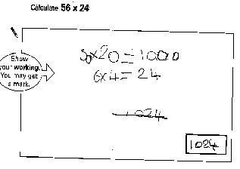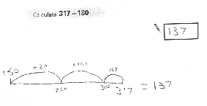For multiplication, when ‘other’ methods were used and the answer was incorrect, evidence of the grid method being taught was seen but the model of the grid was dropped. For example, children recorded only two of the four partial products, most often 50 x 20 and 6 x 4 giving an incorrect answer of 1024 (see Figure 1). This shows that children are not secure with the concept of multiplication when thought of as an array.
Figure 1 Figure 2
For subtraction, there was an obvious distinction between those schools where the number line had been taught exclusively as the calculation strategy compared to those who had offered a wide range. For example, in one school where they had only taught the number line, 41 out of 48 children answering correctly used this strategy. Figure 2 shows a typical example.
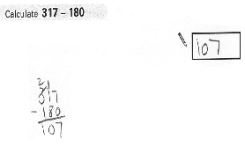Where children answered incorrectly, many had attempted to partition the numbers but then took the larger from the smaller regardless of whether this was appropriate. See Figure 3.
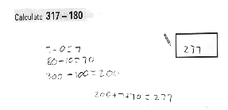Figure 3 Figure 4
One final observation made for subtraction is typified in Figure 4 where children have attempted to use one of the standard written algorithms (in this case decomposition).In this example you can see that the child has some notion of the steps involved in decomposition but is not secure enough to complete the routine successfully.
The most worrying finding for us was the high number of children who had provided either no response or one that suggested they had no strategy available to them for the division question (68% equivalent to 678 children).
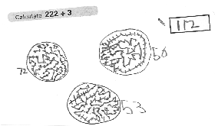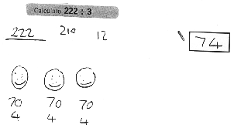The method suggested by the NNS for division is based on ‘chunking up’ or ‘chunking down’ (repeated subtraction or addition using multiples of the divisor). However, the children answering this question used a wide range of methods. These ranged from the almost intuitive (see Figure 5) to the much more individual and inefficient (see Figures 6 and 7). Whilst these two children both have inefficient strategies they do at least show some understanding of the concept of division (as sharing rather than grouping) but they are not ready for a standard algorithm. Figure 8 demonstrates that children who are attempting to use the standard algorithm without a secure knowledge of what division means are unsuccessful.
Figure 5 Figure 6
When approaching multiplication and division questions, and to an extent subtraction questions, many children appeared not to have a strategy at their disposal. For example see Figure 9.

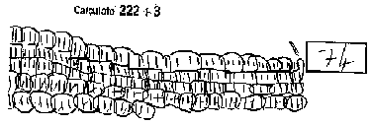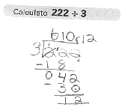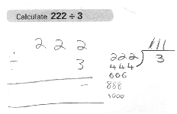conclusion
Figures 7, 8 and 9
The justification for teaching standard written methods according to conversations we have had with teachers, usually centres around neatness, a condensed method, its logic and compactness. Yet as Plunkett (1979) argues “the reasons for teaching the standard written algorithm are out of date” and their existence leads to “frustration, unhappiness and a deteriorating attitude to mathematics”.
As Anghileri notes,
All pupils are expected ultimately to use efficient written methods for calculating
but the only way such methods can be meaningful is if they are developed
progressively to support and extend mental strategies. (Anghileri, 2000, p.108)
This research shows that when children use a strategy, which is based on mental methods, they usually reach the correct solution. Often, children seem not to have any strategies on which to draw, especially if those based on mental methods have not been taught.

REFERENCES
Anghileri, J.: 2000, Teaching Number Sense. London: Continuum.
Clarke, F. & Kamii, C.: 1996, ‘Identification of Multiplicative Thinking in Children in Grades 1-5’. Journal for Research in Mathematics Education, 27 (1), 41-51.
DfEE: 1999, Framework for Teaching Mathematics from Reception to Year 6, London: DfEE.
Plunkett, S.: 1979, ‘Decomposition and all that rot’. Mathematics in school, 8 (3), 2-7.
Stenhouse, L.: 1976, ‘To act in an historical context’. Working memo Number 4,University of East Anglia.
Thompson, I.(Ed): 1999, Issues in teaching numeracy in primary schools, Buckingham: open University Press.

