Calculating: what can year 5 children do?
Alison Borthwick and Micky Harcourt-Heath
University of East Anglia

In 2006 we collected and analysed answers from a Year 5 Qualifications and Curriculum Authority (QCA) test paper to explore the range of calculation strategies used by a sample of children. Two years later in 2008 we repeated this research using the same questions with a new cohort of Y5 children from the same group of schools. In 2010 we carried out a third set of research. This paper reports on the findings from the 2010 data and examines the range of strategies used by the children. We conclude by considering if we are clear about which strategies lead children to success.

Introduction
Despite changes of emphasis within the teaching of primary mathematics in England over the past eleven years, relating particularly to the use of appropriate and effective calculation strategies (DfEE, 1999; DCSF, 2006), the research that we reported on previously (Borthwick & Harcourt-Heath, 2007) indicated that many children still failed to use a strategy that enabled them to reach the right answer.
Calculation strategies in the UK have been well-documented by researchers such as Ginsburg (1977), Hughes (1986), Thompson (1997, 1999) and Anghileri (2000, 2007). Our study focuses on a comparison between different strategies for each of the four calculations, for example, number lines and decomposition for subtraction. The thrust of this research is related to the relative merits of a range of strategies. Some, as will be demonstrated through the outcomes of this research, are more effective for children because they demonstrate transparency, build on mental calculations strategies and are efficient as they result in a correct answer. What seems to be lacking is research relating to the effectiveness of these suggested strategies, built on empirical studies. Our work is a contribution to this field.
Our interest in this is not just because the ability and performance of these children contributes to overall standards when they reach the end of Key Stage 2, but also because, as Bynner identifies:
“Literacy and numeracy skills carry the means by which children are equipped for the education processes on which their location in the adult world will depend”
(Bynner, 2004, P1)

methodology and context
Data was collected from test papers completed by Year 5 children from 22 schools throughout Norfolk. A range of primary and junior schools were selected. Responses to four questions from each of the papers were analysed for their calculation strategies. One question each for addition, subtraction, multiplication and division was used.
Calculation | Question
Addition | 546 + 423
Subtraction | 317 – 180
Multiplication | 56 x 24
Division | 222 ÷ 3
Table 1. Questions from QCA Year 5 test paper
The four questions we selected were chosen as they had no context, and required children to perform a calculation as opposed to less abstract problems that involve children in some interpretation before a calculation can be carried out. The categories used for analysis were determined by the National Numeracy Strategy (DfEE, 1999) and other research (Anghileri, 2000; Plunkett, 1979; Thompson; 1999).

findings and discussion
This section looks at the number of children using each of a range of strategies and the proportions using these successfully. We also include some examples of children’s work.

Addition
90% correct / 10% incorrect
546 + 423 | Number Correct | Number Incorrect | Percentage Correct | Percentage Incorrect
Not attempted |  | 12
Standard algorithm | 269 | 8 | 97.1 | 2.9
Number Line | 27 | 12 | 69.2 | 30.8
Partitioning | 251 | 21 | 92.3 | 7.7
Expanded vertical | 151 | 8 | 95.0 | 5.0
Answer only | 166 | 30 | 84.7 | 15.3
Other | 11 | 7 | 61.1 | 38.9
Totals | 875 | 98
Table 2: Results from 973 children for addition question.
Of the four questions, this was the least useful in terms of providing information about effective calculation strategies because it did not require children to bridge across the tens or hundreds boundaries. According to the data, for correct responses it appears that the standard algorithm is still a significant strategy but the nature of the question masks the difficulties associated with the standard algorithm when ‘carrying’ is involved. Almost a fifth of children giving a correct response only recorded the answer, therefore disguising the strategy employed.

Subtraction
58% correct / 42% incorrect
317 – 180 | Number Correct | Number Incorrect | Percentage Correct | Percentage Incorrect
Not attempted |  | 28
Standard Algorithm – decomposition | 69 | 52 | 57% | 43%
Standard Algorithm – equal addition | 3 | 0 | 100% | 0%
Number Line | 367 | 71 | 84% | 16%
Negative Number | 3 | 0 | 100% | 0%
Counting Up | 23 | 2 | 92% | 8%
Counting Back | 18 | 22 | 45% | 55%
Answer only | 47 | 103 | 31% | 69%
Other | 39 | 126 | 24% | 76%
Totals | 569 | 404
Table 3: Results from 973 children for subtraction question.
While just over half of the children in the study answered this question correctly, this data shows that 4 out of every 10 children are still unable to reach a correct solution. A range of strategies were chosen, with almost 45% of pupils selecting the number line as their method and of these children 84% gained a correct answer.
It is interesting to note that the responses in the ‘other’ category included some where children had added the numbers together. The most random answers were given in the ‘answer only’ category; these ranged from close to the correct answer to what appeared to be guesses, often bearing little or no relationship to the question. The examples below show a typical successful number line strategy and an error made by some children involving partitioning of both numbers and then merely subtracting the smaller from the larger with no regard for the original numbers.

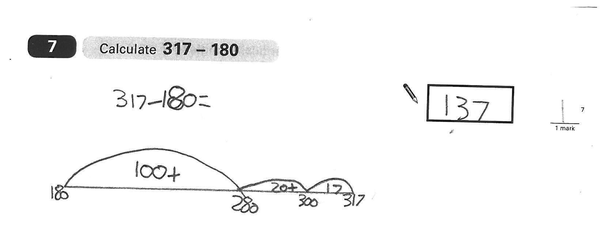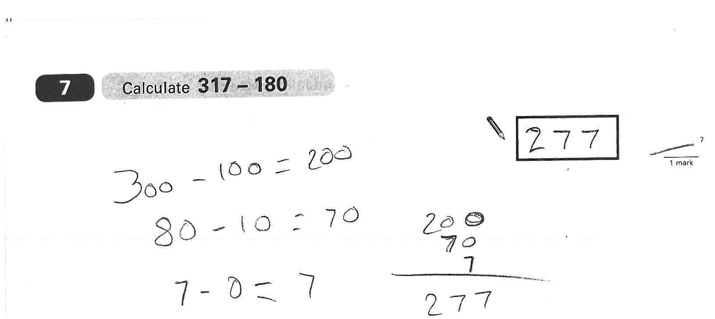

Figure 1 Figure 2

Multiplication
36% correct / 64% incorrect
56 x 24 | Number Correct | Number Incorrect | Percentage Correct | Percentage Incorrect
Not attempted |  | 125
Standard Algorithm | 4 | 15 | 21.1 | 78.9
Grid Method | 329 | 206 | 61.5 | 38.5
Expanded Vertical | 4 | 6 | 40.0 | 60.0
Two partial products only | 0 | 126
Answer Only | 1 | 40 | 2.4 | 97.6
Other | 13 | 104 | 11.1 | 88.9
Totals | 351 | 622
Table 4: Results from 973 children for multiplication question.
Over half of the children chose to use the grid method for completing the multiplication calculation. We were surprised to note that this category had both the highest number of correct (330) and the highest number of incorrect (206) responses.
In terms of numbers of children, the next three most significant amounts of responses appeared under incorrect in the ‘not attempted’, the ‘two partial products’ and the incorrect ‘other’ categories. The two examples below show a fairly typical correct use of the grid method and a representation of the ‘two partial products’ category that more than 10% of the children used.

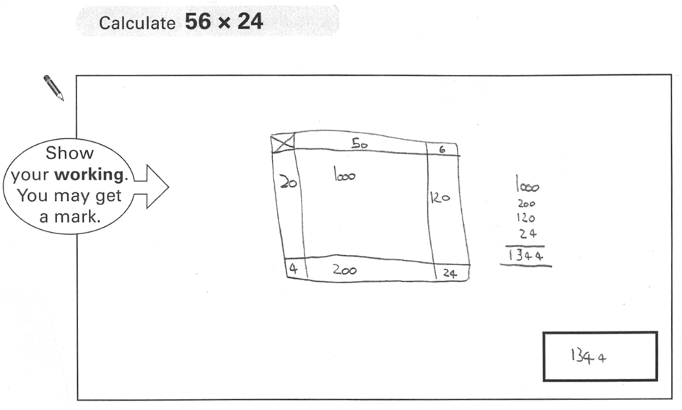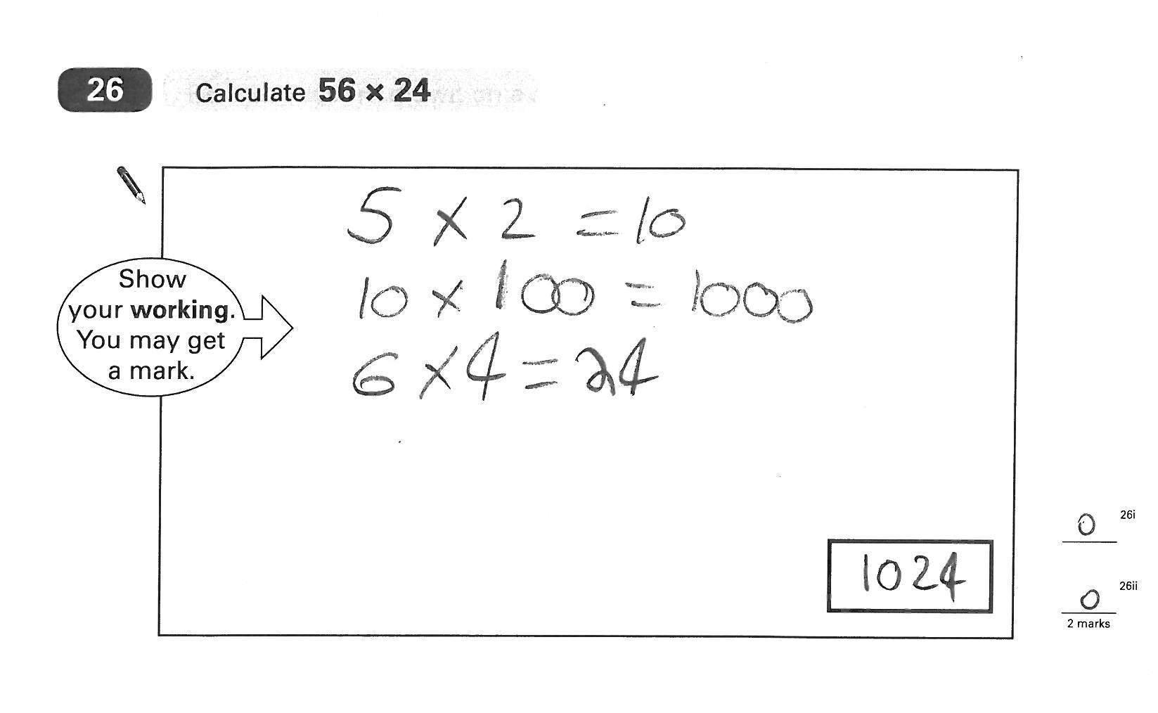
Figure 3 Figure 4

Division
33% correct / 67% incorrect
222 ÷ 3 | Number Correct | Number Incorrect | Percentage Correct | Percentage Incorrect
Not attempted |  | 191
Standard Algorithm | 24 | 18 | 57.1 | 42.9
Chunking Down | 41 | 25 | 62.1 | 37.9
Chunking Up | 98 | 52 | 65.3 | 34.7
Number Line | 89 | 77 | 53.6 | 46.4
Answer Only | 24 | 150 | 13.8 | 86.2
Other | 42 | 142 | 22.8 | 77.2
Totals | 318 | 655
Table 5: Results from 973 children for division question.
This calculation was the least well answered. Almost a fifth of children did not even attempt the question despite it being Question 16 out of 27 on the paper. In addition 18% recorded only the answer without any workings so, whether they were successful or not, there was no indication of the strategy they had employed.
Fewer children selected the standard algorithm over chunking up, chunking down or the number line strategies. Of the children choosing chunking up or chunking down, almost twice as many gained the correct answer as the incorrect one. We were disappointed to note that the number line strategy was less successfully used with almost as many children getting a wrong answer as the right one.
The two examples below show a successful but inefficient strategy and a similar one where the child demonstrates less understanding about what division means.

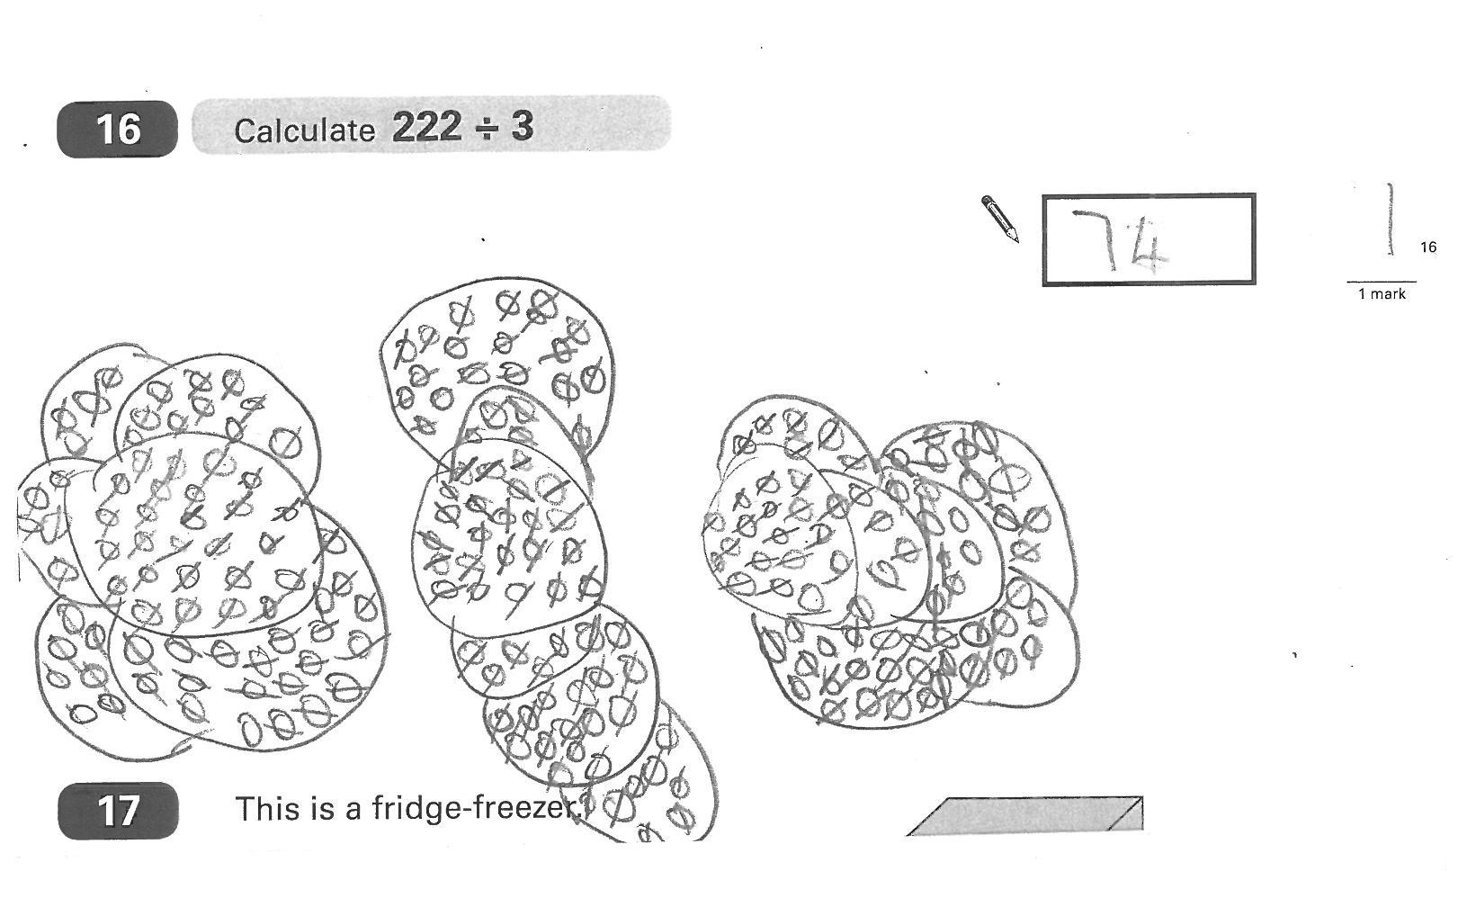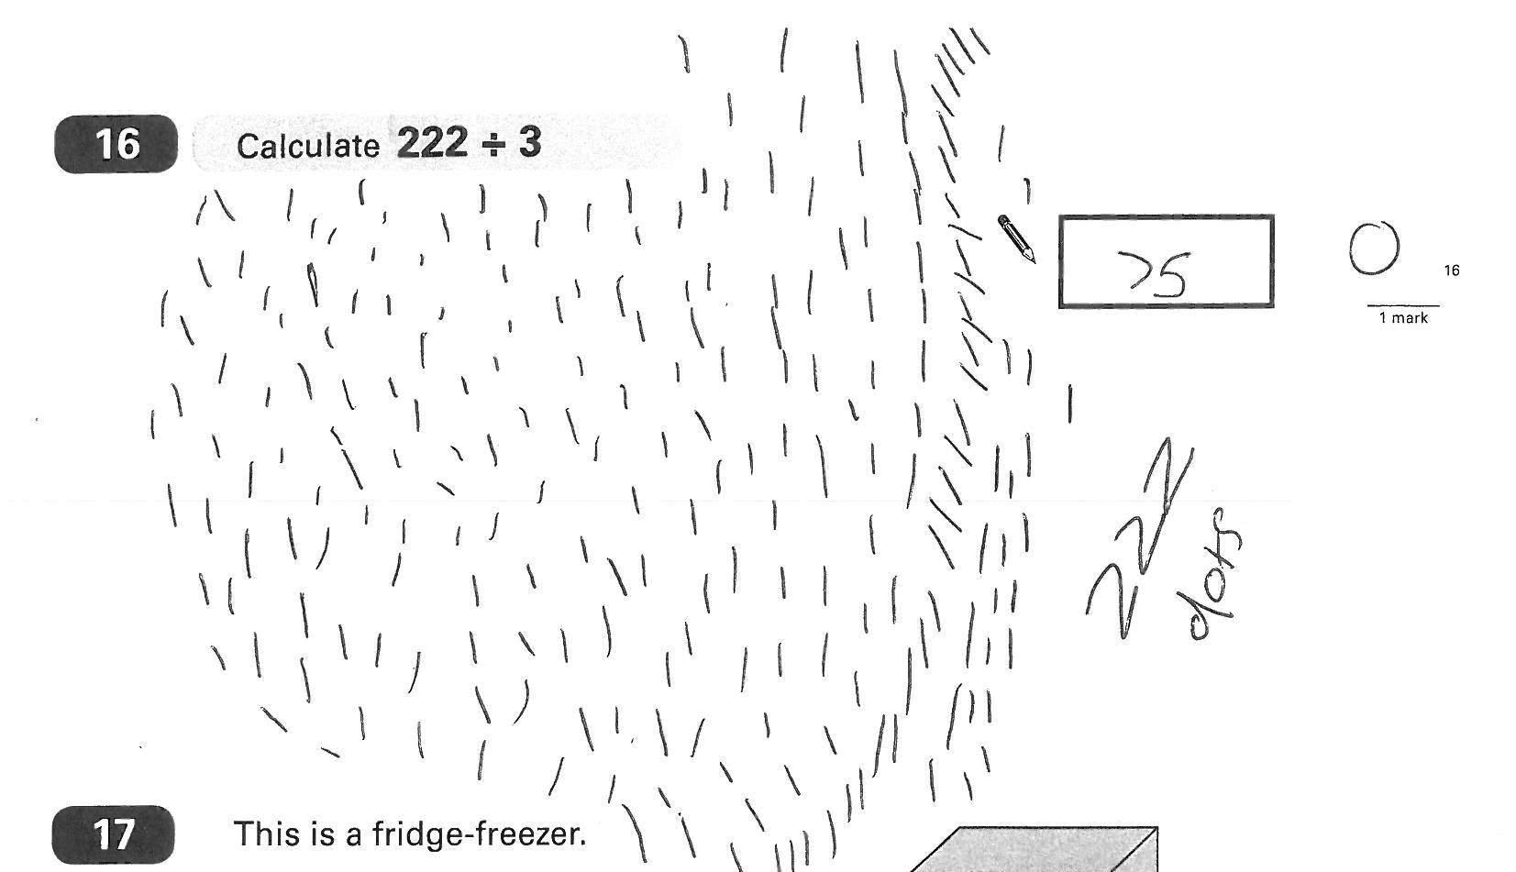
Figure 5 Figure 6

conclusion
The results of this research demonstrate that the more successful strategies are those based on mental calculations, for example, subtraction using counting up and recorded on a number line.
This research shows that children demonstrate higher levels of competence when dealing with addition and subtraction than multiplication and division. It demonstrates for multiplication and division in particular, that children do not seem to have a particular strategy to use. This has implications for schools in terms of what they are including in a Calculations Policy and whether this is being consistently adhered to across the primary years.
In summary, it would appear that many children, at the end of Year 5, still do not appear to have what Anghileri (2000, p1) refers to as, ‘number sense’.

REFERENCES
Anghileri, J. (2000) Teaching Number Sense. London: Continuum.
Anghileri, J. (2007) Developing number sense. London: Continuum.
Borthwick, A. and Harcourt-Heath, M. (2007) Calculation Strategies used by Year 5 Children. Proceedings of the British Society for Research into Learning Mathematics, 27(1), 12-17.
Bynner, J. (2004) Literacy, numeracy and employability: evidence from the British birth cohort studies. Literacy and Numeracy Studies 13(1), 1-48.
DfEE: 1999, Framework for Teaching Mathematics from Reception to Year 6, London: DfEE.
Ginsburg, H. (1977) Children’s arithmetic: the learning process. New York: D. Van Nostrand Company.
Hughes, M. (1986) Children and number: difficulties in learning mathematics. Oxford: Blackwell.
Plunkett, S.: 1979, ‘Decomposition and all that rot’. Mathematics in school, 8 (3), 2-7.
Thompson, I. (Ed) (1997) Teaching and learning early number. Buckingham: Open University Press.
Thompson, I.(Ed) (1999) Issues in teaching numeracy in primary schools, Buckingham: Open University Press.

